Santa Clara University Bronco Invitational
Saturday, October 13th, 2012
Baylands Regional Park, Sunnyvale, CA
Final entries must be submitted online at runnercard.com
by Monday, October 8th @ 12:00am (Pacific Time).

Schedule of Events
Saturday, October 13th, 2012

Alumni/Community Fun Run 8:00am

Women’s 5k Open at 9:00am

Women’s 5k Invitational at 9:45am

Men’s 8k Invitational at 10:30am

Men’s 8k Open at 11:15am

Entry Fees:
Teams:
USATFCCCA Members: $150 per gender
Non USATFCCCA Members: $200 per gender
Individuals:
$20 per unattached individual

Dear Coach,

Welcome to the 2012 Santa Clara University Bronco Invitational. This year’s event will take place two weeks prior to Conference Championship weekend and provides a flat and fast course.

Baylands Regional Park is located in Sunnyvale, California, approximately 10 miles North of Santa Clara University at the Southwest end of the San Francisco Bay. The course at Baylands consists of low cut grass and hard packed dirt paths, with a few short paved sections.

Entries into the invitational sections will be limited to the top 10 athletes per team due to the narrow nature of the course. The invitational section will consist of the top ranked collegiate teams as determined by NCAA Cross Country Coaches polls and meet management. Meet staff will determine which teams will be admitted into the invitational sections in order to keep the field to a safe and manageable number and preference will be given to D1 teams. Entry in the invitational section is not guaranteed. If you wish to register your team for the invitational section, email the meet director at pete.cushman@gmail.com to request a password for online registration. Also, unattached athletes are welcome to participate in the open sections.
Please email our meet director, Pete Cushman, if you have any questions or concerns at pete.cushman@gmail.com.
Best regards,

Felipe Montoro

Felipe Montoro
Head Coach
Santa Clara University
Cross Country and Track

How To Enter (Schools and Individuals)

- Registration for the 2012 Bronco Invite will be done online at www.runnercard.com. You can find the meet in the collegiate section, or follow this link: http://www.runnercard.com/e/runner.Main?meet=3581

- We will NOT accept entries via telephone, fax or e-mail. All entries must be done through www.runnercard.com by the published deadlines. To create an account at www.runnercard.com you only need a user name and password and follow the easy directions.

- Just a reminder, if you want to register your team for the invitational sections, we are limiting the size of those races to keep them safe, manageable and competitive. Email pete.cushman@gmail.com to request the meet access code.

5k Course Map
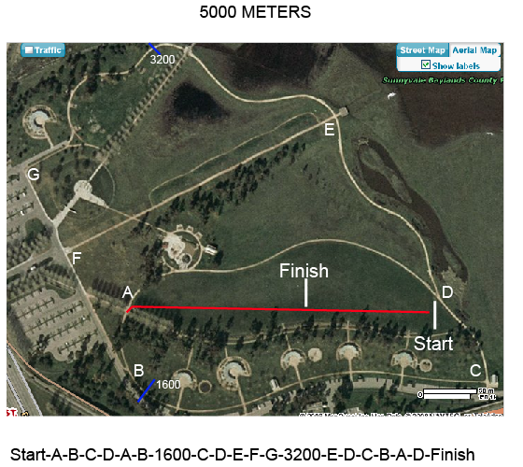

8k Course Map
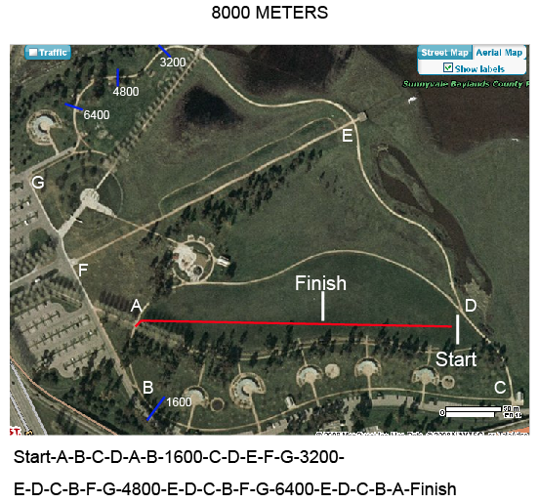

Packet Pick Up
Friday, October 12th, 3:00-5:00pm PST @ Baylands Regional Park
Saturday, October 13th, 7:30-9:00am PST @ Baylands Regional Park
Chip Timing
This year’s event will be IPICO chip timed by Red Cap Timing, www.RedCapTiming.com.

- ALL athletes MUST wear the corresponding Bib/Chip. DO ensure athletes attach their chip firmly to the top of their shoe using the enclosed bubble security ties.
- ALL athletes MUST wear the corresponding numbered chip.
- Athletes should NOT put their timing chip in their pocket or arm.
- ALL chips MUST be returned and/or collected after each race at the finish line or the packet pick-up location.
- There is a $30 charge for each chip not returned. Your chip is not disposable. We will collect your timing chip at the finish line for re-use at another event.
- Turn in your roster sheet (with changes) AND ALL UNUSED CHIPS before the start of your respective race(s).

Please mail any found chips to:
Red Cap Timing
1441 Spring Valley Drive
Roseville, CA 95661
Location & Directions
999 East Caribbean Drive
Sunnyvale, CA 94089-1111
(408) 730-7751
*Parking is $6.00 per vehicle. Do not park in un-marked spaces or the City will tow your vehicle. Overflow parking is available next to Baylands at the Twin Creeks Softball complex
From San Francisco:
Take US-101 S toward I-80 E/Oakland/San Jose. Take the exit onto CA-237 E toward Alviso/Milpitas. Take exit 5 for Caribbean Dr. Merge onto Lawrence Expy. Continue onto Caribbean Dr. Turn right at Baylands Park.
From Sacramento:
Take I-80W to I-680 S (signs for Benicia/San Jose). Take the Mission Blvd/State Route 262 exit toward I-880. Keep right at the fork, follow signs for Mission Blvd W and merge onto Mission Blvd/State Route 262. Take the ramp onto I-880 S. Take the exit onto CA-237 W toward Mountain View. Exit onto Caribbean Dr. Turn right at Baylands Park.
From San Jose:
Take CA-87 N to US-101 N toward San Francisco. Take the Lawrence Expy exit. Turn right at Lawrence Expy. Continue onto Caribbean Dr. Turn right at Baylands Park.
Lodging
The Sheraton San Jose is offering a special rate to teams participating in the Bronco Invite. For other hotel accommodations near Santa Clara University, please visit:
http://www.scu.edu/map/visiting/index.cfm
Additional Information
Trainers will be present on race day by 8:00am
The first five finishers per school will score; the next two will displace. Runners on incomplete teams will not count toward team scoring.

The finish line is in the direct center of the timing mats.
Feel free to contact us if you have any questions. See you on the 13th!
pete.cushman@gmail.com

Head Coach Felipe Montoro, 408-554-4688, mmontoro@scu.edu

Assistant Coach and Meet Director, Pete Cushman, 408-554-4886, pcushman@scu.edu

