2022 UIAAA Cross Country Invitational
This is the Utah Interscholastic Athletic Administrators Association hosted endowment meet. Since the invitational is an endowment meet, the UHSAA has granted approval to have the UIAAA Invitational not count towards each athlete’s maximum total of meets for the season.
Date: Saturday August 27, 2022
Time: 8:0am
Location: Spanish Fork Sports Park Sports Complex
295 West Volunteer Drive, Spanish Fork UT 84660
Cost: $90 per team ($180 per school) OR $5.00 per runner. Up to 40 runners per gender. Add $2 per runner over 40 per gender.
Make Checks Payable to UIAAA or pay via MySchoolFees
https://secure3.myschoolfees.com/guest_home.aspx?sid=126&feegroupid=5270

Schedule: 8:00am Frosh/Soph JV Girls Race
8:30am Frosh/Soph JV Boys Race
9:00am Varsity Girls
9:25am Varsity Boys
9:50am Jr/Sr JV Girls Race 1 Schools A-L
10:15am Jr/Sr JV Boys Race 1 Schools A-L
10:40am Jr/Sr JV Girls Race 2 Schools M-Z
11:05am Jr/Sr JV Boys Race 2 Schools M-Z
11:40am Awards
Awards: Medals for the Top 15 finishers in each Varsity Race and for the Top 10 finishers in the JV races. Team Plaques for top two teams in the Varsity Races
Registration: Registration is online at www.runnercard.com. Registration opens on June 6th and closes on Thursday August 25th at 8pm. We will take the first 30 full teams.

Course: Newly designed 3 mile course run predominantly on grass. There are a few sections of concrete to cross over walkways. Spikes are allowed.
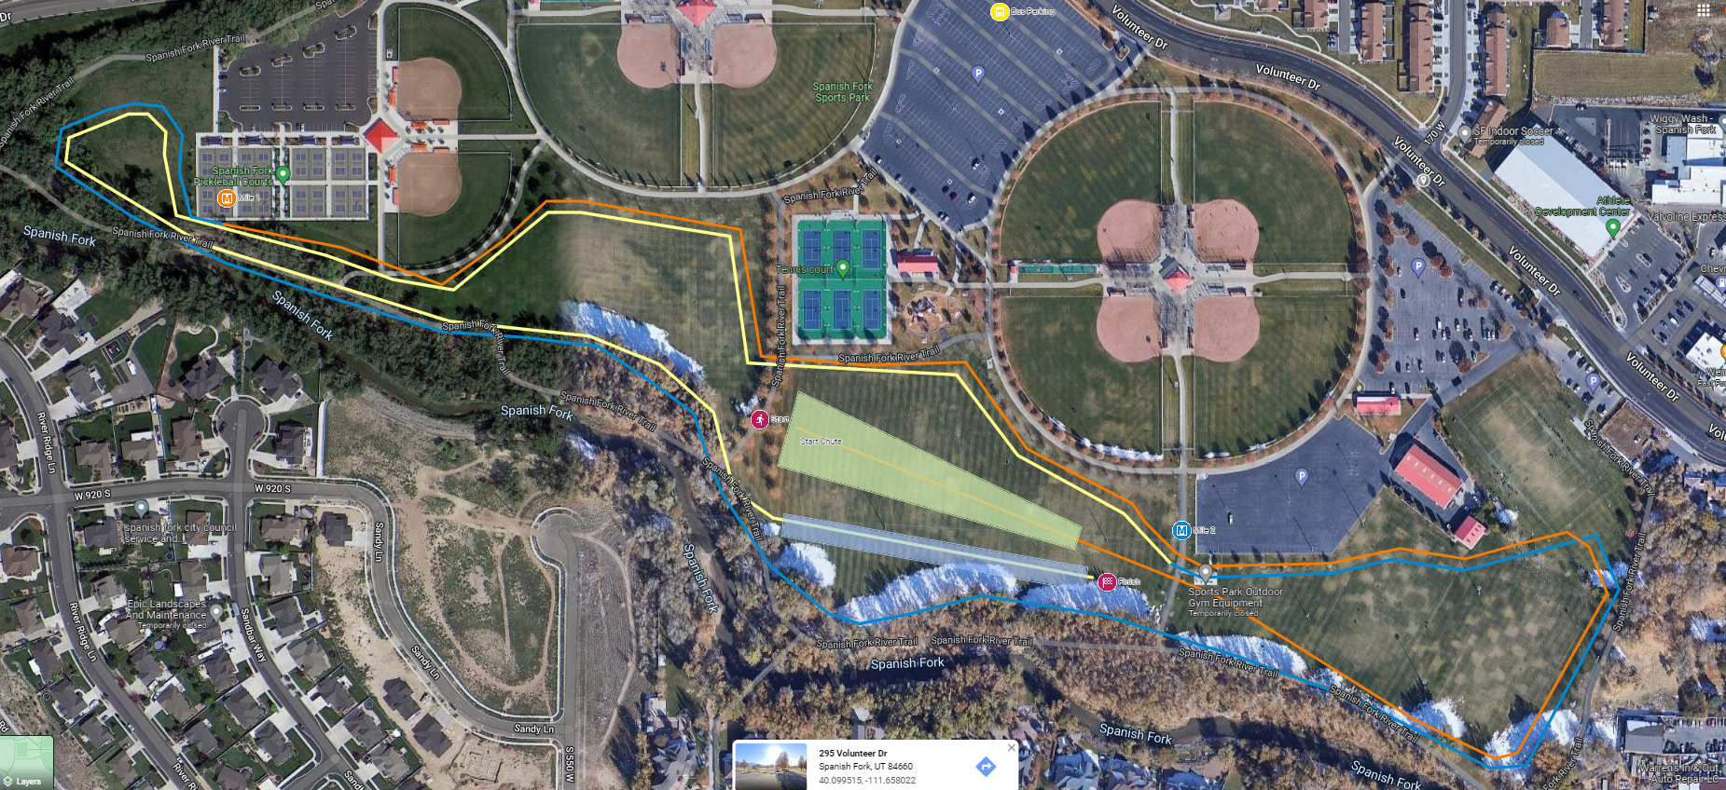

Contact Info:
David Boyack Darin Cable Marc Hunter
david.boyack@nebo.edu darin.cable@nebo.edu hutch80ad@yahoo.com
801-358-3975 801-319-4268 801-560-0854
Please park busses in the north side of the large parking lot directly north of the tennis courts. Better yet have the busses drop you off and leave the facility during the races.

