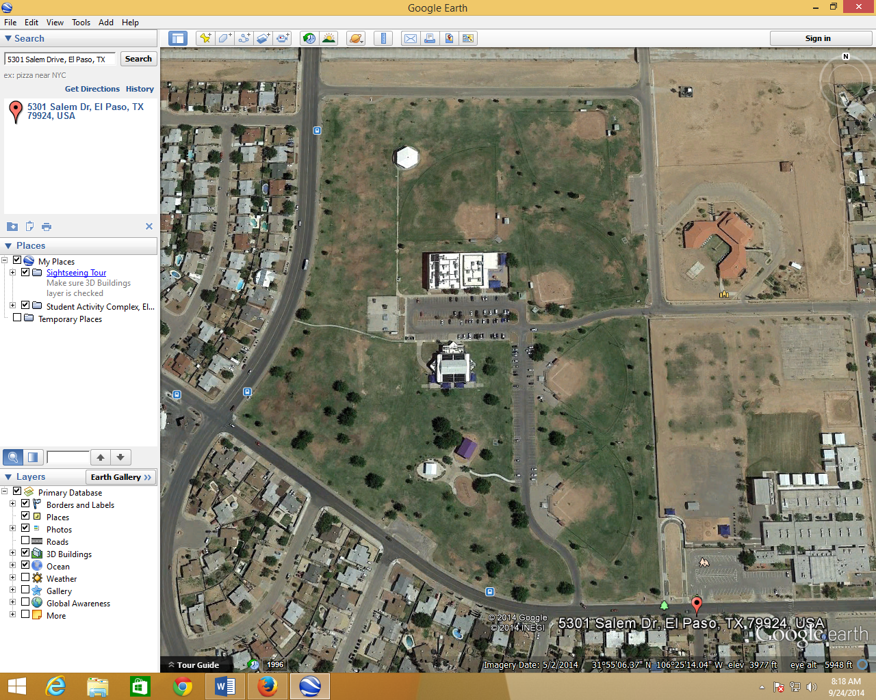
START
FINISH
CROSS COUNTRY MEET
VETERANS PARK

COURSE BEGINNING & END IS LOCATED CLOSE TO THE INTERSECTION OF RUSHING & SALEM STREET.

START LINE IS LOCATED ON THE LEFT SIDE OF THE OF SKATE PARK.
THE COURSE WILL START ON THE FIELD BY THE SKATE PARK THEM RUN BEHIND THE SWIMMING POOL AND MAKE ITS WAY TOWARDS THE PERIMETER OF THE PARK
RUNNERS WILL BE RUNNING ON THE GRASS WITH THE SIDEWALK ON THEIR LEFT AND FLAGS ON THEIR RIGHT SIDE FOR MOST OF THE COURSE.
ON THE BACK END OF THE PARK, THEY WILL PASS 2 BASEBALL FIELDS. FOLLOWING THE PERIMETER UNTIL THEY ARE ROUTED IN BETWEEN THE SECOND FIELD AND ANOTHER BASEBALL FIELD. THEN MAKE THEIR WAY ALONG THE BACK END OF THE 1ST BB FIELD, UNTIL THEY REACH A GIANT LIGHT POLE. RUN UP TO GO AROUND THE GAEZEBO. THEN HEAD BACK IN THE DIRECTION OF THE 1ST QRT. OF THE COURSE IN THE OPPOSITE DIRECTION. FROM THE CORNER OF THE SKATE PARK, THEY WILL TAKE A LEFT DOWN INTO THE LAST STRETCH OF THE COURSE INTO THE CHUTE. THE CHUTE WILL BE PAST TWO LARGE MULBERRY TREES THAT ARE CLOSE TO SALEM STREET.

*RED ARROWS INDICATE DIRECTION TO THE FINISH LINE.

