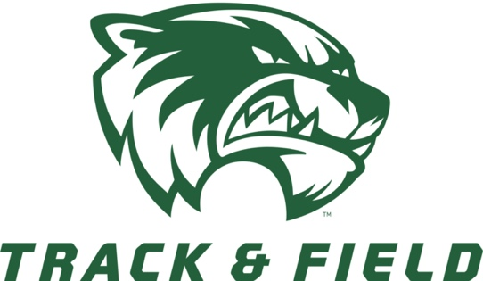

Utah Valley University
UVU HAL WING Collegiate Invitational
Final
(Revised 3/31/21)

Location: Hal Wing Track and Field
Date: April 2-3, 2021 (Friday and Saturday)
Gender: Male and Female
Entry Fee: $300.00 per gender ($600.00 for both male and female teams)
Checks to: Utah Valley University
Registration: Runnercard.com
Registration Deadline: REGISTRATION WILL CLOSE. April 1, 2021 at 12:00pm MST
Allowed Entries: All College teams. Unattached athletes must be with and a current athlete on a college roster (have a COVID test within 72 hours of their first event)

Meet Director Contact Information:
Name: Nelson Orton
Office Phone: 801-863-6783
Email: runninrex@gmail.com
Name: Chris Shane
Cell Number: 801-652-5213
Email: Chris.shane@uvu.edu

Note From Meet Director:
Hal Wing Track and Field
1200 W 800 S
Orem Utah 84058

Spectator Entry fee: $5.00 for ages 6 and up (each Day). Max of 500 spectators.
Must wear wristband and mask ALL day

Spectator and Athlete Parking: Lot L-14

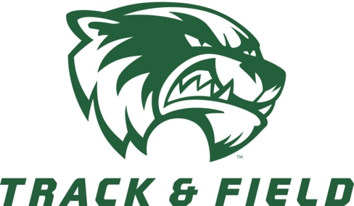

Utah Valley University
Track and field
Schedule of Events
Field Events
 | Friday  Implement Weigh-in 8:00a – 11:30  10:00 Javelin women  Javelin men  10:00 Triple Jump women  Triple Jump men  1:00 Hammer women  Hammer men  12:00 Pole Vault women  Pole Vault men |  | Saturday  Implement Weigh-in 9:00a – 11:30  10:00 High Jump women’s  High Jump men’s  10:00 Shot Put Women’s  10:00 Men’s Discus  12:00 Shot Put men’s  12:00 Discus Women’s  12:00 Long Jump women’s  Long Jump men’s
Running Events
 | Friday (Trials)  12:00 100m women trials  12:15 100m men trials  12:30 5000 women finals  12:50 5000 men finals  1:30 100mH women trials  1:45 110mH men trials  1:55 1500 Women finals  2:15 1500 Men finals  2:40 200m women trials  3:00 200m men trials |  | Saturday (Finals)  10:00 4X100 women finals  10:10 4X100 men finals  10:20 Steeple women  10:35 Steeple men  10:55 100mH women final  11:05 110mH men final  11:15 400m women  11:25 400m men  11:35 100m women final  11:45 100m men final  12:00 800m women  12:15 800m men  12:30 400mH women  12:45 400mH men  1:00 200m women final  1:10 200m men final  Senior Recognition  2:00 4x400m women  2:10 4x400m men

All times are listed in Mountain Time
MEDICAL INFORMATION
Utah Valley University and the UVU Athletic Department are committed to the safety and well-being of all athletes, staff and administrators who will participate in athletic competition at UVU. In consultation with our sports medicine staff, our team doctors we have established the following protocols for our Track and Field competitions hosted at UVU.
These recommendations will be policy for the 2021 season. Considering the evolving nature of this pandemic, all protocols may be updated periodically, and changes will be communicated to the appropriate parties within a reasonable time frame if our medical staff determines that changes need to be made.
Testing Protocols
Each institution is responsible for the health, safety and wellness of its own student-athletes and staff and is subject to the restrictions imposed by its individual state and local health departments. In addition, all visiting teams are required to meet or exceed the Utah Valley University testing protocols as outlined in this document.
Testing Protocols
- UVU requires testing for SARS-CoV-2 virus (COVID-19) utilizing either antigen or polymerase chain reaction (PCR) testing. Prior to competition, the official travel party of both teams will be required to perform a test no earlier than 3 days prior to competition.
- All coaches, athletes and staff traveling to the competition site should be included in the testing protocol..
Affidavit
- The visiting team must provide an affidavit signed by the Team Physician & Athletic Director or Sport Administrator, affirming that the tests were conducted as outlined above. The affidavit must include the names of each individual member of the travel party and must be sent to UVU at least 24 hours prior to competition.
WAC Attestation Form
https://docs.google.com/forms/d/e/1FAIpQLSdl0C9ZKu2QZBWckjA0PHHuSfdkG4sktTUFCHg29CVhwVdYnA/viewform
Participation after Positive Results
- The Western Athletic Conference (WAC) protocol states Individuals who have tested positive more than 10 days before competition are not required to participate in the testing protocol for 150 days from the date of positive test. It is the responsibility of the Team Physician and Athletic Director or Sport Administrator to approve the participation of that athlete on the affidavit.
- Asymptomatic Individuals
  - Individuals who test positive for COVID-19 who are asymptomatic must isolate for 10 days from the date of their first positive COVID-19 test.
  - After isolation has been completed the asymptomatic athlete may participate in the contest if:
    - They are cleared by their team physician to resume athletic participation.
    - AND The team Physician signs the appropriate paperwork disclosing the initial positive test date and certifying that each athlete in question has followed and completed the appropriate CDC designated isolation period.
- Symptomatic Individuals
  - Individuals who test positive for COVID-19 and experience mild to moderate symptoms will undergo quarantine a minimum of 10 days from the day of their positive test result AND must be symptom free for the last 3 days of the quarantine period without the use of any medications to reduce fever or any other COVID-19 symptoms.
  - After the quarantine has been completed the athlete may participate in the contest if:
    - They are cleared by their team physician to resume athletic participation.
    - AND the team Physician signs the appropriate paperwork disclosing the initial positive test date and certifying that each athlete in question has followed and completed the appropriate CDC designated isolation period.
Contact Tracing
Per CDC, Local Health Department and State guidelines each school must contract trace their athletes with a positive test to determine high risk contacts in the 48 hours preceding the collection of the positive test sample.
High Risk contact
- Per the CDC, a High-Risk contact is defined as the following:
  - Those with prolonged close contact (>15 minutes cumulative within 6 feet over 24hrs) during the period of 2 days prior to a positive test until the onset of isolation, while one or both parties were not wearing a mask.
- Individuals who have had a High-Risk exposure to COVID-19 will be required to undergo a mandatory 10-day quarantine without a PCR test, or 7-day quarantine with a negative PCR test when administered a minimum of 5 days after the quarantine began, based on NCAA and CDC guidelines.
- These individuals may return to athletic participation at the end of the 10-day quarantine period as long as they are asymptomatic without the use of any medication to control any symptoms of COVID-19 for the last 3 days of their quarantine.

Isolation Protocol
Prior to Travel:
- Any individual who tests positive 10 days or less from the date of travel is not allowed to travel due to not having sufficient time to complete the required isolation period.
- Individuals with High-Risk exposure who have not completed their quarantine may not travel.

During Travel:
- If an individual(s) tests positive or develops COVID-19 symptoms while traveling, that individual(s) shall be placed in isolation and not participate in the competition or accompany the team onto Utah Valley University’s campus.
- Contact tracing for that individual needs to be done immediately with appropriate quarantine of any High-Risk exposures that occurred during the trip.
After Travel
- The visiting team agrees to notify UVU of any athlete who participated in the contest who tests positive in the 2 days following the contest. Disclosure need not identify the individual by name but should include the positive individual’s role on the team as well as a summary of their interactions with the opposing team. UVU will reciprocate the reporting in the same manner with the visiting team.
- This information shall be shared as quickly as possible, no later than 24 hours after the receipt of positive results.
Track Area
Each team should maintain appropriate social distancing throughout the competition.
No Prospective Student Athletes (PSA’s) will be allowed on the track or in the locker room at any time on game day as they have not passed the appropriate COVID testing and screening protocols.
Locker Rooms
Teams should arrive dressed and ready for competition. Restroom facilities will be available throughout the meet, but private locker rooms are not available.
Facial Coverings

All individuals on both teams with access to the team locker room, track and competition area will be required to wear an appropriate facial cover at all times while on the UVU campus (no face shields unless accompanied by a cloth face covering per UVU campus policy).

Student athletes competing are not required to wear a facial covering while on the track. As they return to team areas off the track, they should put the facial covering back on.

Coaches shall wear a facial covering at all times.

Pregame Screen
We trust that visiting team(s) medical personnel will screen all of their visiting athletes and staff using the UVU Daily Standardized Screening Assessment via provided link https://uvu.qualtrics.com/jfe/form/SV_26sJPLU63IZ5dAh?Type=Athletics (or QR code also provided) prior to coming to UVU each day of competition and if someone has a fever or symptoms they must stay at the team hotel.
Upon successful screening they will be allowed access to the areas designated for their position and game day responsibilities.

