2021 CLINT INVITATIONAL
The Clint Track & Field team and coaches would like to invite you to the 2021 Clint Invitational to be held on Friday February 26, 2021. This is a one day meet with two divisions. Varsity division will compete in the morning, starting at 9:00 am. JV will compete in the afternoon beginning at 3:00 pm.
NO JV athletes will be allowed at the meet until all the Varsity athletes have left.
POLE VAULT IS ON THURSDAY AT MT VIEW @ 3:00PM!!!!!!!!!!
8:30-9:00 am-please have your athletes get all their steps and run-throughs so we can begin on time. Remember as per UIL- no running backwards on the runways
V: 9:00 am- girls high jump
*boys triple jump *girl’s long jump
*boys discus *girl’s shot put
*(each Varsity jumper/thrower will have 3 jumps/throws and top 8 advance to finals-3 additional jumps/throws.)
V: 10:00 am- boys high jump
*boys long jump *girls triple jump
*boys shot put *girls discus
*(each jumper/thrower will have 3 jumps/throws and top 8 advance to finals- 3 additional jumps/throws)
JV WILL HAVE 4 JUMPS/THROWS…NO FINALS!!!!!!!!!!!!!!!
Running- will be timed finals in all events
9:00 am- V girls 3200 meters followed by the V Boys
After the 3200’s we will allow relays to practice handoffs
Rolling schedule (girls followed by boys)
4x100 relay (girls followed by boys)
800 meters
100 /110 meter hurdles
100 meters
4x200 relay
400 meters
300 hurdles
200 meters
1600 meters
4x400 relay
The afternoon session will follow the same format. All events that start at 9:00 am will begin at 3:00 pm.
ALL Varsity athletes will have to leave the stadium before the JV can arrive and start competition.
Coaches information and working assignments:
Parking Information:
- Buses will park in the east side parking lot of the stadium.
- We will have security to help guide you to the gate you will need to enter through.
Security:
- You will need to screen and temp. check all your athletes before they come to the meet. (Please send me a copy-915-2769968).
- All athletes and coaches will also have their temperature checked as you enter the gate.
- If anyone has a temperature over 100 degrees, they will need to be re-screened after 10 minutes. If their temperature is still over 100 degrees, they will have to leave the meet and their coach will have to monitor their pickup
- NO FANS are allowed at the meet
Bathrooms:
- Bathrooms on home side and visitor side will be open. Concession will be closed.
- Only one person will be allowed in a restroom at a time. There will be someone to monitor this but we need your help. Please tell your athletes this rule and please help to enforce it at all times.
Safety:
- There will be several hand sanitation stations around the field to use
- Trash cans will be located on the field – please have your kids clean up their area
- We must clear the entire area between the Varsity and JV session- including fogging the stands.
- Please have your teams clear out as quickly as possible
- Varsity teams cannot leave the bus or enter the meet before this has been completed
- Each team must bring their own throwing implements. Teams may NOT share
- Workers/coaches need to bring their own tape measurer, clip board, pencils and measuring sticks to work the event assigned to you
- Hand sanitizer stations will be located around the field for your use
- Remind kids that high fives, hugs, jumping on each other, etc. is not allowed and they need to remain 6 feet apart at all times.
Trainers:
- Our trainers will provide water at the finish line
- Please tell your athletes to bring their own water bottles to the meet
- There will be a station for the athletes to refill their bottles as needed
- Please have your athletes taped and treated before they come to the meet. Our trainers will be there to assist any new injury at the meet but not to tape kids before they compete.

Team Areas:
- Each team will have a designated area in the stands and your team must remain in that area when they are not warming up or cooling down.
- Each team will also have a designated warm up/cooling down area on the football field. This is the only area that they will be allowed to warm up or cool down in. NO team camps.
- Please have your kids/coaches remain in the stands when not warming up or coaching- NO camps or you will not have any room to warm up
- Please have you kids use the hurdles in their warm-up area only. Please do not move hurdles in or out of that area.
- Each area in the stands will be marked with your team name.
- Coaches need to assure their athletes are social distancing in the stands and on the field.
- Masks should be WORN by all coaches and athletes except for when they are competing.
- NO food or drinks, other than water is allowed on the field at any time.

Additional Information:
- Trash cans will be located around the field, please have your kids clean up their area
- Hospitability will not be provided at the meet
- Concessions stand will NOT BE open.
- Please have your kids be aware of flagged area. They need to watch out for jumpers on the runways and high jump area and be careful around the throwing area
- Remind the kids that they can no longer run backwards on the runways (UIL guidelines)
- Athletes using profanity may be disqualified from the event or meet
- Only tennis balls/TAPE or soft small items are allowed on the track for relays- no rocks
- Kids need to report to their field events to get marks 30 minutes prior to the start of the event
- Athletes will be called from the warm-up area to the running events for check in, please have them listen
and report on first call- we need to stay on schedule for the afternoon
- Blocks will be provided and located near the start of each race.
- Medals will be given to 1st -3rd and placed in a team envelope and will be delivered to each school two days after the meet.
WORKING ASSIGNMENTS: - coaches please provide 2 adults that are knowledgeable in the event assigned. Please bring your own tape measure and measuring stick, clipboard, pencils, etc. with you. This is necessary with the UIL COVID guidelines, so we don’t share too many items. These will not be provided for you. You will be responsible for both divisions in the morning and afternoon, so you will work Varsity and JV girls and boys.
Field Event:
Long Jump: SAN ELI Triple Jump: MONTWOOD
Discus: RIVERSIDE Shot Put: EL PASO
Pole Vault: MT VIEW High Jump: BEL AIR
Relay Exchanges:
1st exchange and 800 break in- HORIZON (400, 800 and 1600 relay)
2nd exchange- HORIZON /CLINT (400 and 800 relay)
3rd exchange- HORIZON /CLINT (400 relay and 800 relay)
Finish Line/Timers: CLINT/HORIZON Medals- CLINT
Clerks: CLINT Hurdle setters: CLINT
Starters: CLINT
If you have any questions or concerns for me, please feel free to call me at (915) 276-9968 or email me at ROSUEL.MARTINEZ@CLINT.NET
COACH MARTINEZ

MEET WILL BE STREAMED @
https://sites.google.com/clint.net/clint-isd-athletics/home?authuser=2

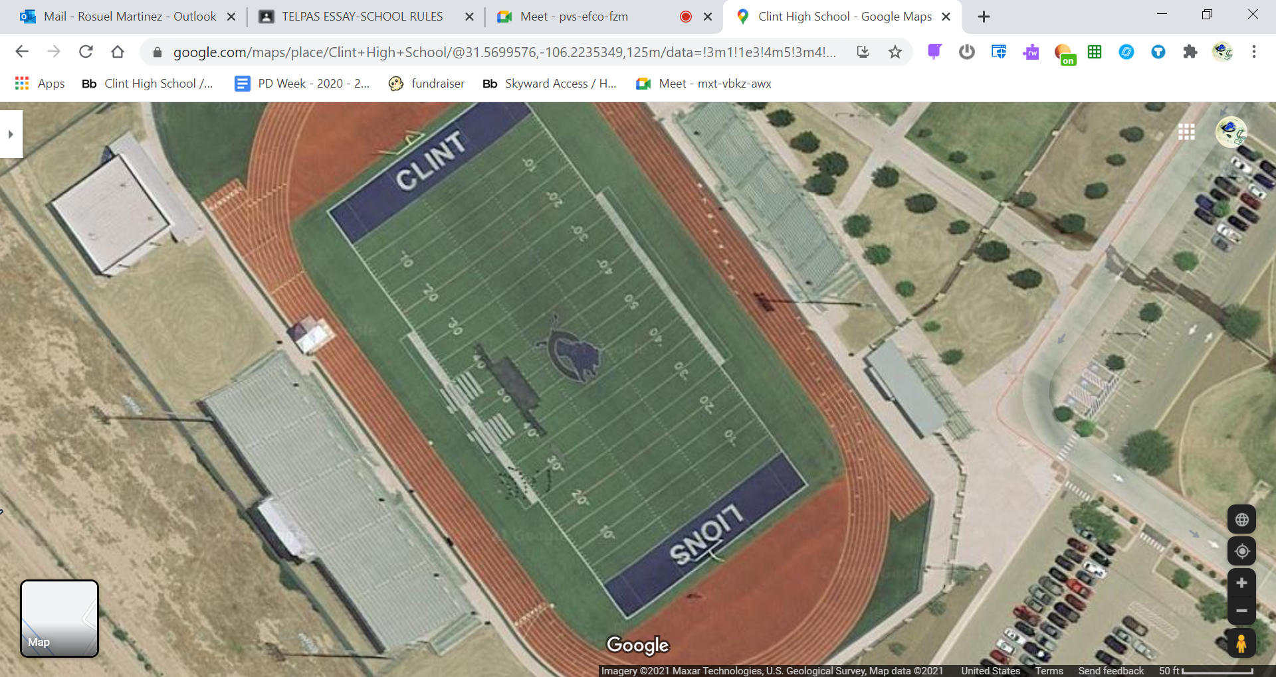
SEATING AREA FOR EACH TEAM
HORIZON MONTWOOD SAN ELI BEL AIR
CLINT EL PASO MT VIEW RIVERSIDE

