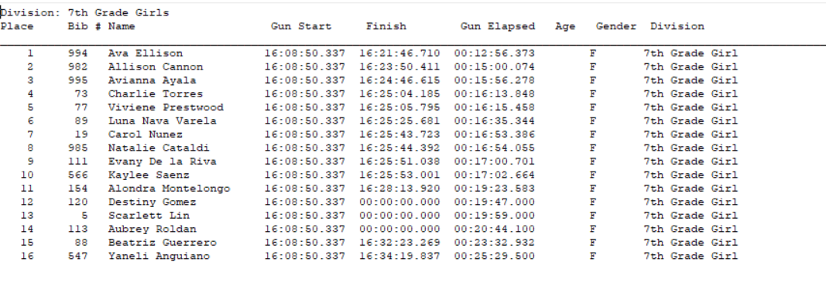
7th Grade Girls: Overall Time is listed as Gun Elapsed Time:

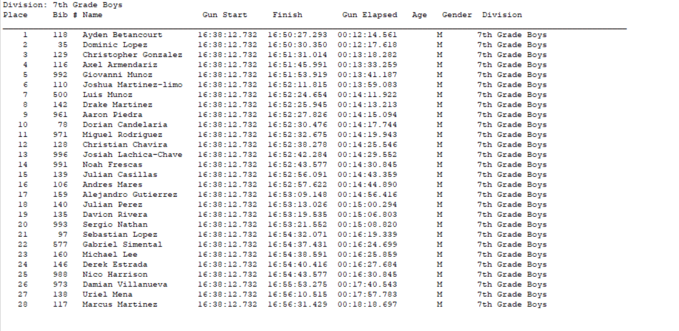
7th Grade Boys: Overall time is listed as Gun Elapsed Time
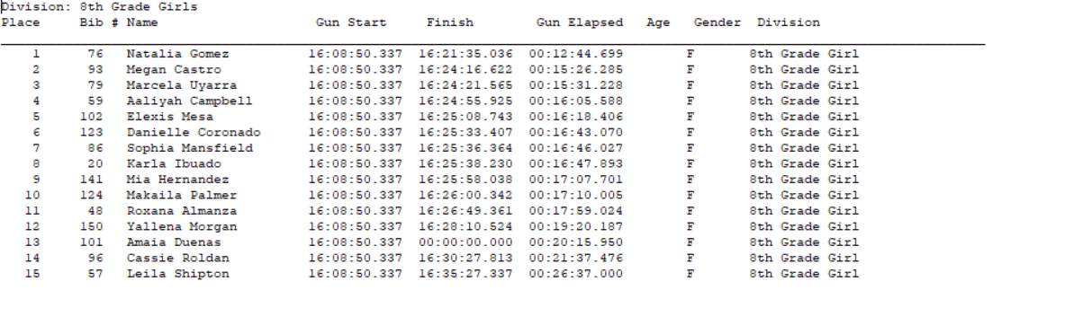
8th Grade Girls: Overall Time is listed as Gun Elapsed Time:

8th Grade Boys: Overall Time is Gun Elapsed Time:
