HANKS EXCALIBUR INVITATIONAL 2021

UPDATED COACHES INFORMATION- PLEASE READ

TIME SCHEDULE CHANGE:
VARSITY 3200- new start time is 9:00 am
VARSITY 4X100 RELAY- new start time is immediately after the 3200 finish

PLEASE TELL YOU KIDS THIS IS A ROLLING SCHEDULE AND TO BE READY FOR THEIR EVENTS

NEW WORKING ASSINGMENTS-
VARSITY BOYS AND GIRLS LONG JUMP- ANTHONY HS
RELAY EXCHANGE #3 – ANTHONY HS

PLEASE VIEW THE MAPS ON PARKING, ENTRY AND SEATING- LET ME KNOW IF YOU HAVE ANY QUESTIONS-only one gate will be open to the track

We may be able to have open pits at the long and triple jump if numbers stay low- we will decide by Friday

Please remember to bring all your items needed to run your event and please remind the kids to practice social distancing and wear their masks

Reminder- only one athlete in a restroom at one time. We are bringing in extra porta-potty for the kids to use as well.

Please remind your kids they cannot run backwards on the runways

Relay exchange judges- please remember that exchanges may take place between the international zone area and the last large triangle

Our track exchange colors are:
4x100 – yellow
4x200- green, green, and yellow
4x400-blue

SEE YOU ALL ON FRIDAY
Kim Gomez
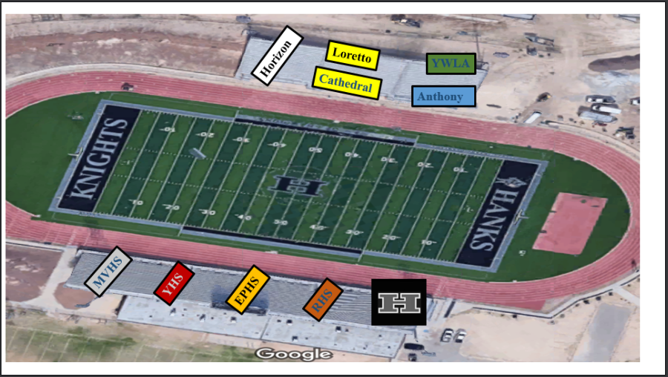
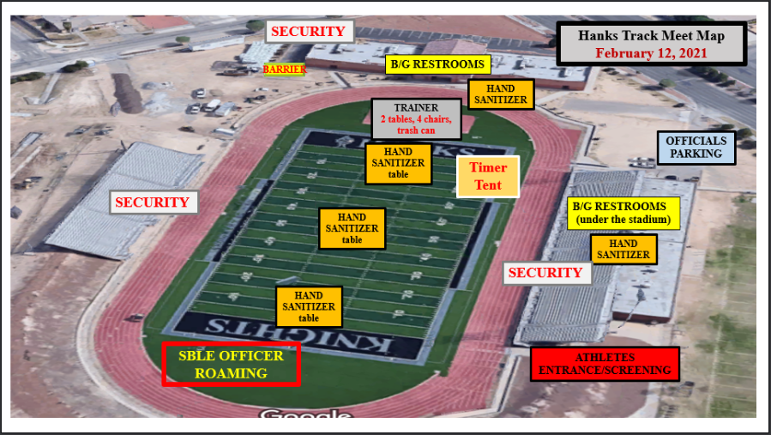

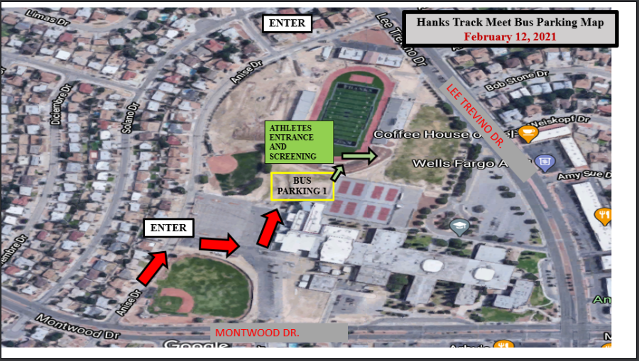

Hanks 2021 Excalibur Invitational

Welcome to the 2021 Track and Field Season! It has been a long time coming and I know we all hope we can make it all the way through!

The Hanks Track and Field team and coaches would like to invite you to this year’s Excalibur Invitational to be held on Friday February 12, 2021.

This is a one day meet with two divisions. Varsity will compete in the morning, starting at 9:00 am.
Junior Varsity will compete in the afternoon beginning at 3:00 pm.

NO JV athletes will be allowed at the meet until all the Varsity athletes have left.

8:30-9:00 am-please have your athletes get all their steps and run-throughs so we can begin on time. Remember as per UIL- no running backwards on the runways

Varsity: 9:00 am- boys pole vault girls high jump
*boys triple jump *girl’s long jump
*boys shot put *girl’s discus
*(each jumper/thrower will have 3 jumps/throws and top 8 advance to finals- 3 additional jumps/throws)

10:00 am- boys high jump girls pole vault
*boys long jump *girls triple jump
*boys discus *girls shot put
*(each jumper/thrower will have 3 jumps/throws and top 8 advance to finals- 3 additional jumps/throws)

Running- will be timed finals in all events
10:00 am- Varsity girls 3200 meters followed by the Varsity Boys
After the 3200’s we will allow relays to practice handoffs
11:00 am- Rolling schedule (girls followed by boys)
4x100 relay (girls followed by boys)
800 meters
100 /110 meter hurdles
100 meters
4x200 relay
400 meters
300 hurdles
200 meters
1600 meters
Weight man’s relay- throwers only
4x400 relay

The afternoon session will follow the same format. All events that start at 9:00 am will begin at 3:00 pm and those that start at 10:00 am will begin at 4:00 pm

ALL Varsity athletes will have to leave the stadium before the JV can arrive and start competition.

Coaches information and working assignments:

Parking Information:
- Buses will need to enter through the Fine Arts parking lot off of Anise and will continue to the dirt parking area near the tennis courts to park.
- We will have security to help guide you to the gate you will need to enter through.
- ALL team members and coaches will have to enter through this one gate
- All other gates around the school will be locked

Security:
- You will need to screen all athletes before they come to the meet. All athletes and coaches will have their temperature checked as you enter the gate
- If anyone has a temperature over 100 degrees, they will need to be re-screened after 10 minutes. If their temperature is still over 100 degrees, they will have to leave the meet and their coach will have to monitor their pickup
- NO FANS are allowed at the meet

Bathrooms:
- Bathrooms will be open next to the concession stand.
- Only one person will be allowed in a restroom at a time. There will be someone to monitor this but we need your help. Please tell your athletes this rule and please help to enforce it at all times.

Safety:
- There will be several hand sanitation stations around the field to use
- Trash cans will be located on the field – please have your kids clean up their area
- We must clear the entire area between the varsity and JV session- including fogging the stands.
- Please have your Varsity teams clear out as quickly as possible
- JV teams cannot leave the bus or enter the meet before this has been completed
- Each team must bring their own throwing implements. Teams may NOT share
- Workers/coaches need to bring their own tape measurer, clip board, pencils and measuring sticks to work the event assigned to you
- Hand sanitizer stations will be located around the field for your use
- Remind kids that high fives, hugs, jumping on each other, etc. is not allowed and they need to remain 6 feet apart at all times.

Trainers:
- Our trainers will provide water at the finish line
- Please tell your athletes to bring their own water bottles to the meet
- There will be a station for the athletes to refill their bottles as needed
- Please have your athletes taped and treated before they come to the meet. Our trainers will be there to assist any new injury at the meet but not to tape kids before they compete.

Team Areas:
- Each team will have a designated area in the stands (4 teams per side) and your team must remain in that area when they are not warming up or cooling down.
- NO team tents in the stands- umbrellas are welcome
- Each team will also have a designated warm up/cooling down area on the football field. This is the only area that they will be allowed to warm up or cool down in. NO team camps.
- Please have your kids remain in the stands when not warming up- NO camps or you will not have any room to warm up
- Please have you kids use the hurdles in their warm-up area only. Please do not move hurdles in or out of that area.
- Each area in the stands and field will be marked with your team name/mascot
- Coaches need to assure their athletes are social distancing in the stands and on the field
- Masks should be worn by all coaches and athletes expect for when they are competing.
- NO food or drinks, other than water is allowed on the field at any time

Additional Information:
- Trash cans will be located around the field, please have your kids clean up their area
- Hospitability will not be provided at the meet
- Concessions stand will be open with prepackaged food and drinks
- Please have your kids be aware of flagged area. They need to watch out for jumpers on the runways and high jump area and be careful around the throwing area
- Remind the kids that they can no longer run backwards on the runways (UIL guidelines)
- Athletes using profanity may be disqualified from the event or meet
- Only tennis balls or soft small items are allowed on the track for relays- no tape and no rocks
- Kids need to report to their field events to get marks 30 minutes prior to the start of the event
- Athletes will be called from the warm-up area to the running events for check in, please have them listen and report on first call- we need to stay on schedule for the afternoon
- Blocks will be provided and located near the start of each race.
- Medals will be given to 1st -3rd and placed in a team envelope for the coach to collect at the end of the meet

Coaches, please watch for an email early next week with a map of all the team areas, parking areas and other important information.

WORKING ASSIGNMENTS: - coaches please provide 2 adults that are knowledgeable in the event assigned. Please bring your own tape measure and measuring stick, clipboard, pencils, etc. with you. This is necessary with the UIL COVID guidelines, so we don’t share too many items. These will not be provided for you. You will be responsible for both divisions in the morning and afternoon, so you will work Varsity and JV girls and boys.

Field Event:
Long Jump: YWLA Triple Jump: Ysleta
Discus: Horizon HS Shot Put: Loretto/Cathedral
Pole Vault: Mt. View HS High Jump: El Paso HS

Relay Exchanges:
1st exchange and 800 break in- Hanks and Horizon (400, 800 and 1600 relay)
2nd exchange- Cathedral/ Loretto, Mt. View and El Paso (400 and 800 relay)
3rd exchange- YWLA and Ysleta (400 relay and 800 relay)

Finish Line/Timers: Riverside and Hanks Medals- Hanks
Clerks: Hanks HS Hurdle setters: Hanks
Starters: Hanks HS

If you have any questions or concerns for me, please feel free to call me at (915) 203-3949 or email me at kgomez@yisd.net
Kimberly Gomez
Head Girls and Boys Track and Field

