Onate Rob Winter Cross Country Classic Invitational
March 13, 2021

Date: March 13, 2021
Place of Event: Onate High School
Starting Time: 3:00 PM
Coaches Meeting: Packet Pickup Only.

Onate High School and Coaching Staff would like to invite you to the 2021 Onate Rob Winter Classic Cross Country Invitational. Please make sure to read all requirements, regulations and rules for the meet. We are excited to host you and your teams and give you an opportunity to compete safely.
Thank you,
Coach David Nunez
Home#: 575-382-9003
Email: dnunez@lcps.net

Meet Description: This meet will be a staggered and wave meet. Each school may travel to the Onate Rob Winter Invite with a total of 14 boys (7 Varsity/7 JV) and 14 girls (7 Varsity/7 JV) to compete. JV/Varsity Divisions will be combined so that all boys are competing in one race and all girls in another.

Rob Winter Classic (WAVE ASSIGNMENTS)
Wave | Time | Event | Schools
Session 1 | 3:00 PM | Girls Combined | Onate, Las Cruces Alamogordo,Centennial, Mayfield, Santa T
 | 3:30  PM | Boys Combined | Onate, Las Cruces, Alamogordo, Centennial, Mayfield, Santa T
Session 2 | 4:00 PM | Girls Combined | Deming,Cloudcroft, Hot Springs, Chaparral, Mescalero,Gadsden
 | 4:30 PM | Boys Combined | Deming, Cloudcroft, Hot Springs, Chaparral, Mescalero, Gadsden

Course Description: The course consists of some grass, dirt, sand, road pavement and finishes on the football field.

Arrival and Parking:
Please arrive no earlier than 45 minutes prior to your team/waves race time. We have to clear the session before the next one can start.

Las Cruces High School, Mayfield High School, Centennial and Onate High School will park in the East Parking Lot in the back of the school by the soccer fields. Athletes will check in with their Head Coach and go as a team to their designated warm up area.

Schools traveling by bus will enter the Bus Parking Entrance of Onate which is located in the back of the school. You have been designated a bus parking spot and porta potties to be used for your team only.

Designated Warm-up Area:
Area 1 (Girls Soccer field) – Las Cruces, Onate, Santa T, Chaparral
Area 2 (Boys Soccer field) – Mayfield, Centennial, Hot Springs, Mescalero
Area 3 (Softball field) – Alamogordo, Cloudcroft, Deming, Gadsden

Restrooms: The bathrooms are located near the track for local teams. Only one athlete at a time will be permitted into the bathroom. Please adhere to social distancing and masks while in line.
Onate- Locker Room Bathroom
Las Cruces,Centennial, Mayfield track side bathrooms
Deming, Alamogordo, Cloudcroft, Gadsden, Hot Springs, Mescalero, Santa T, Chaparral bus parking porta potties which will be marked on map.

Race Procedure: No warm ups or cool downs on course. All warm up and cool downs take place in designated team areas. Session waves will report to the starting line 15 min. prior to the race. No team huddles in front of the starting line. Teams will be 6 ft apart in assigned team boxes and must stay in their box lanes for first 50 meters before cutting in toward the gate exit.

Awards: Results will be posted on runnercard. NO hard copies will be given out or posted at the meet.
There will be no awards ceremony and awards will be packaged and given to the Head Coach at a later date.

Meet Requirements: You need to sign up at http://runnercard.com You may have to set up an account if you do not have one. It is free. If you have any questions, feel free to contact me.
Meet Entries are due by March 11, 2021 @ 10:00 PM. We will be using BOTH Numbers and the HYTEK software for the meet. You will be given a roster with Numbers assigned to each of your runners to be written at least 3 inches on their hands and left shoulder so that they can be identified. A spotter and recorder will record the athletes by their number as they cross the finish line. A video of the finish will be used as a backup for recording if needed.

Map of Onate Rob Winter Classic Course
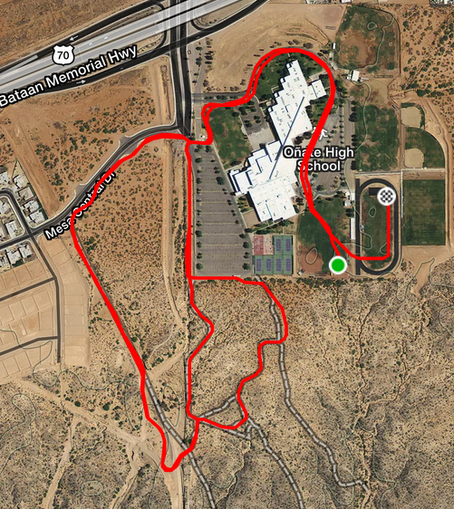

Map for Warm Up and Bus Parking
