2024 Taylorsville Invitational
Date: Second Saturday in April (4/13/2024)
Start Times: Running events begin at 8:00 AM. Implement weigh-ins open at 7:30 AM and will finish by 8:30 AM. All field events open at 8:00 AM for warm-ups.
Location: Taylorsville High School Track; 5225 S Redwood Rd., Taylorsville UT

Registration: All athletes must be entered into Runnercard by Thursday, April 11th, at 6PM. Each athlete can be registered for up to 4 events. Schools can register up to 5 athletes per event per gender. For running events, enter only varsity athletes (with times as available). For field events, please follow the minimum marks below.
- Boys Discus: 95'
- Girls Discus: 70'
- Boys Javelin: 100'
- Girls Javelin: 60'
- Boys Shot Put: 30'
- Girls Shot Put: 25'
- Boys Long Jump: 17'
- Girls Long Jump: 13'
- Boys High Jump: 5' 6" (raised 2" until 6' 6" then 1")
- Girls High Jump: 4' 4" (raised 2" until 5' 6" then 1")
- Boys Pole Vault: 9' 0" (raised 6" until 14' then 3")
- Girls Pole Vault: 7'0" (raised 6")
  - Pole vault starting height might change slightly based on the state qualification marks for 6A.
Cost: Cost is $250 per school, which includes all runners, or $6 per athlete for 4 events. There are two different ways to pay:
- Checks: Checks should be made out to “Taylorsville High; CO: track”. Before the Invitational checks can be sent to Taylorsville High and addressed to the bookkeeper, Lafo Tonga; on the day of the meet a check can be given to the meet director. If you send a check to Taylorsville High please make sure that the name of your school is attached to the check.
- Credit card over the phone: If you would like to pay using a credit card over the phone, please call the main office at Taylorsville High School and ask to be transferred to the finance office. The office is open from 8 AM to 2 PM. The phone number for the Taylorsville High office is 385-646-5455. Make sure you tell the individual taking your credit card info what school you are from.
Awards: For individual events, medals will be given out for places 1-6. For relays, medals will be given out to places 1-3.
Tickets for Spectators: Tickets can be purchased at tinyurl.com/tvilletracktix or with cash on the day of the event. Tickets are $10 for individuals and $20 for families.
Additional Information:
- The 4 x 200 meter relay will be run with a 4 turn stagger.
- Spectators will not be allowed in the competition area for pole vault. Spectators can watch the event either from the north side of the stands next to the pole vault competition area or on the sidewalk outside the chain-link fence next to the pole vault competition area.
- The medley relay will be available for 1A, 2A, and 3A schools. The 4 x 200 meter relay and the 4 x 800 meter relay will be available for 4A, 5A, and 6A schools. Please only sign up for your respective relays. If for the Medley Relay we can combine girls and boys in one heat, we will do so. If your school is from outside of Utah and you compete in both the 4 x 200 and the 4 x 800 at your respective state meets, you will be allowed to enter athletes into both relays.
- Food will be available at the concessions stand.
- Free lunch will be available for each team’s coaches (up to 5 meals total) and will be available between 11:30-12:00. When it is announced that lunch is available please send one of your coaches to the concessions stand to pick up the food.
Contact Info: Chad Farnes; cfarnes@graniteschools.org; 385-222-6846
- On the day of the meet, if you need to contact me please text. It will be easier for me to respond.
- If you need to find me, I will be wearing a Wheres Waldo striped shirt.

2023 Taylorsville Invitational
Order of Running Events
This is a rolling schedule. 4 x 800 Meter Relay will start at 8:00 AM. Running will begin with girls, followed by boys.
4 x 800 Meter Relay
100/110 Meter Hurdles
100 Meter Dash
4 x 200 Meter Relay
Medley Relay
1600 Meter Run
4 x 100 Meter Relay
400 Meter Dash
300 Meter Hurdles
800 Meter Run
200 Meter Dash
3200 Meter Run
4 x 400 Meter Relay

Field Events
Implement weigh ins open at 7:30 AM. All pits open at 8:00 AM for warm-ups.
1st Wave

Girls Pole Vault
Girls Javelin
Boys Discus
Girls High Jump
Girls Shot Put
Boys Long Jump

2nd Wave

Boys Pole Vault
Boys Javelin
Girls Discus
Boys High Jump
Boys Shot Put
Girls Long Jump

MAP OF INVITATIONAL
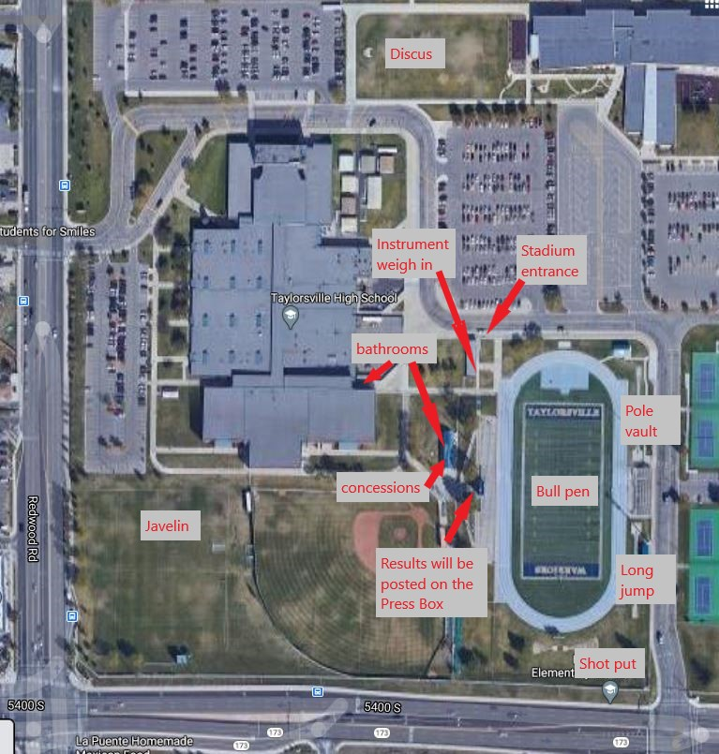

Estimated schedule based on times from 2023
The following schedule are estimated times for each event based on the 2023 meet. Please be aware that these times are only estimates; the meet will be conducted on a rolling schedule and if we are ahead of this schedule, we will continue with the meet. Please ensure that you are at your events with enough time.

Start time: Event Name
8:00 AM: 4 x 800 Meter Relay
8:20 AM: 100/110 Meter Hurdles
9:00 AM: 100 Meter Dash
10: 15 AM: 4 x 200 Meter Relay
10:40 AM: Medley Relay
10:50 AM: 1600 Meter Run
12:10 PM: 4 x 100 Meter Relay
12:40 PM: 400 Meter Dash
1:40 PM: 300 Meter Hurdles
2:30 PM: 800 Meter Run
3:30 PM: 200 Meter Dash
5:00 PM: 3200 Meter Run
6:30 PM: 4 x 400 Meter Relay
7 PM: Meet finishes

